**WEEK 6**

**Practice Occupational Health and Safety**

**Definition of Terms**

**Bacteria** – a simple, single celled microorganism. They food , moisture and warmth to thrive.

**Electroshock** - caused by touching exposed electrical wire or a piece of electrical equipment which is not grounded properly.

**Force Majure**- a calamity caused by nature e.g. storm, flood, earthquake

**Grounded** – means that the electrical conductor is connected to the ground, which becomes part of the electrical circuit

**Hazard** – a situation that could be dangerous to people in the workplace

**Microorganisms** –are living cells so small that they they can only be seen in a microscope. They are commonly found to contaminate food – bacteria, molds, and yeast.

**Molds** – also a microorganism, that has “furry” growth often found on spoiled food.

**Sanitation** – the science and practice of maintaining clean and healthy conditions of food production so that the food served to customers cannot make him ill.

**Toxin** – a poisonous substance that makes you sick

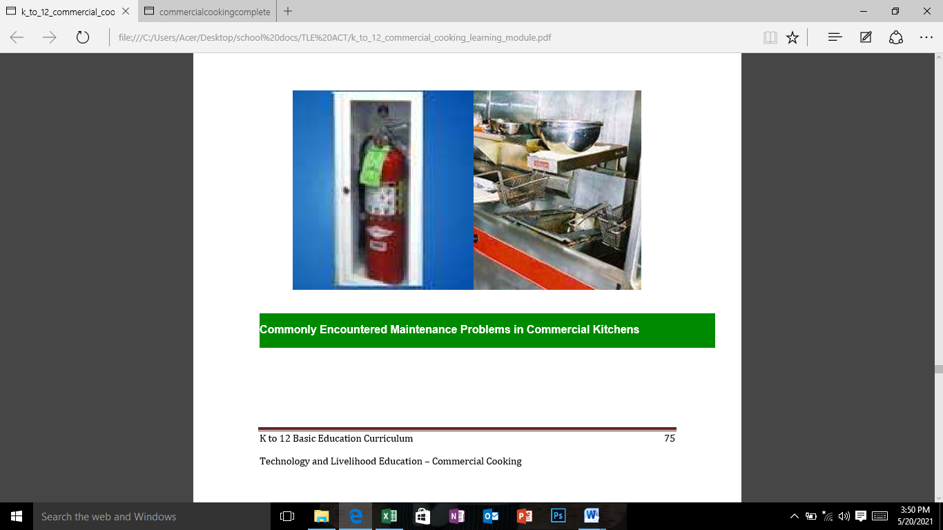

The commercial kitchens are the production units of any organizations whether it is a Hotel, Restaurant, Banquet or any other business outlet like Fast Food, or road side eateries. These kitchens consist of mostly white powder coated metallic false ceilings stainless steel kitchen equipments and kota stone flooring. In some kitchen, we may find aluminium sheet false ceiling. The light fittings are recessed in false ceiling and have Perspex cover over the fluorescent tubes to avoid any glass breakage falling in food items. The kitchen equipment are operated with electricity, LPG, Coal and water.

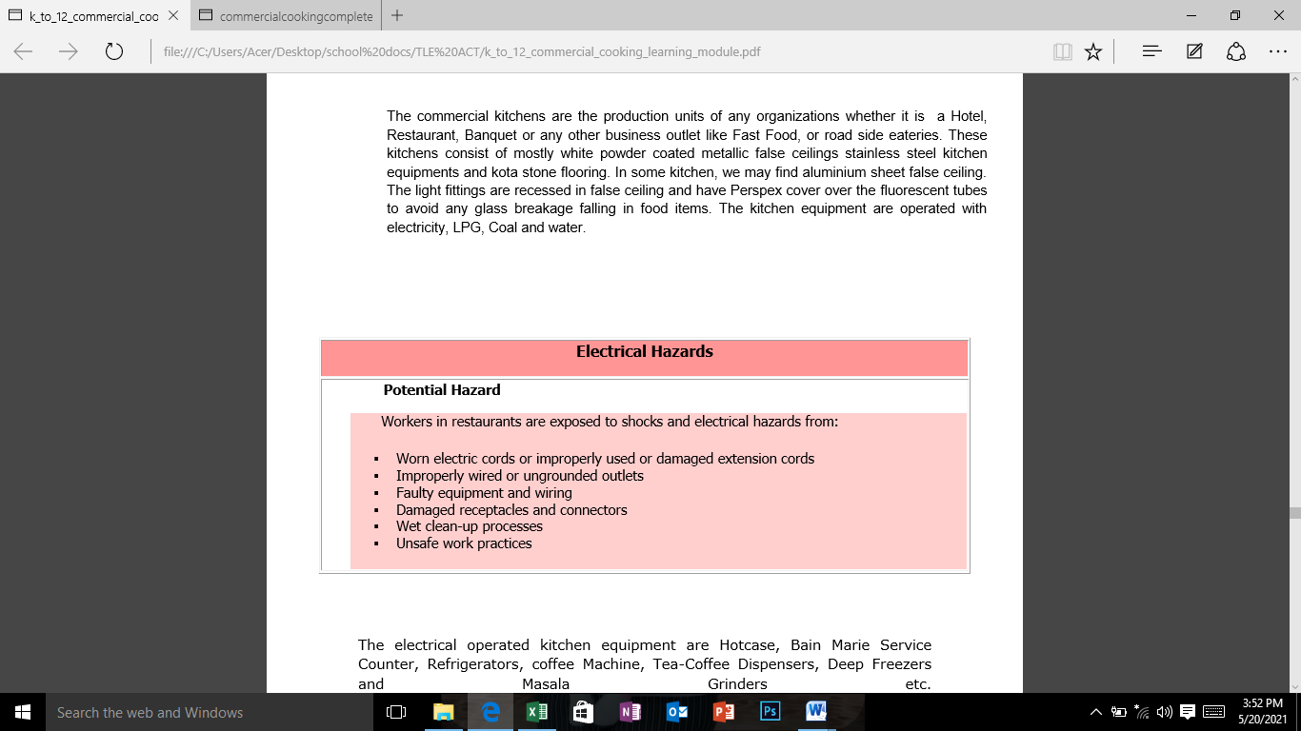

We face many **problems in these commercial kitchens** on a day to day use and these are listed below:

**(a) Electrically operated kitchen equipment:**

Tripping of miniature circuit breakers because of wrong selection in terms of capacity, short circuiting etc.

Short circuiting of air heaters being used in Hot cases and service counters for continuously long hours usage.

Burning of Immersion heaters of Bain marie when sufficient water quality is not available in the Bain Marie.

Short-circuiting of electrical wiring by putting water on electrical switches while cleaning the kitchen during night hours by unskilled worker.

**(B) LPG Operated Kitchen Equipment:**

The cooking ranges are operated on LPG and if LPG supply is not maintained properly, it may cause the problem of fire in kitchen.

Smoke created by continuous use of LPG in commercial kitchen.

The hoods over the ranges should have filters to control oil and Grease, otherwise the smoke carried along with oil and Grease shall cause problems of fire is exhaust chimney.

The LPG operated equipment have burners which needs to be cleaned regularly to avoid mishap.

The oil, grease used in cooking and production of food items to be handled properly otherwise spillage over LPG operated equipment can cause problem of fire.

**(C) Water Operated Kitchen Equipment:**

Dish washing machines needs electricity and water both. As the water mixes with chemicals used for cleaning the plates, glasses, etc. the water and chemicals create mishaps and hazards.

The equipment like cooking ranges, Chinese Cooking Range, Griddle Plate, Oven and Bakery Oven are operated on LPG. The tandoors in kitchen are operated with coal. The dishwash sink, counter sink and bain marie etc. need cold water and hot water for their use. We face many problems in these commercial kitchen in a day to day use.

**Apply health, safety and security procedures in the workplace**

Running a business in a cafeteria or a big food service establishment is a demanding job. Consider the following responsibilities if you are a worker or an owner of such business.

• Protecting your property from fire;

• Protecting your property from natural hazards;

• Protecting your property from crime;

• Protecting your staff and visitors from accidents;

• Legislation that may affect your business.

*Most kitchen fires occur in kitchen ranges, boilers or deep-fat fryers and can often be traced back to poor cleaning regimes.*

**A. Protecting Property from Fire**

• Ensure that cooking ranges, boilers and deep-fat fryers are fitted with thermostats or emergency cutoff valves to turn off the fuel supply should a fire break out.

• Ensure that filters are removed and de-greased frequently to prevent a build up of greasy deposits.

This should be done weekly but you may need to consider more frequent cleaning if the equipment isused for long periods on a daily basis.

• Store all combustible materials away from buildings or perimeter fencing – preferably inside locked waste bins or lidded skips. Ensure they are emptied regularly. If no suitable outside location is available, use a secure internal storage area.

• Be vigilant when you open and close the premises each day – look for signs of potential trouble e.g.graffiti or damage to fences – remove graffiti and repair any damage immediately to deter further damage occurring.

**Electrical faults**

Prevention of faults is the answer here and this can be achieved by:

• Frequent visual inspections of all portable electrical items and fixed electrical wiring.

• Regular maintenance of these items by an authorized agency or licensed electrician may be recodred and monitored.

Smoking Ideally smoking should be prohibited throughout the premises (including yards and open areas) and notices to that effect prominently displayed.

• Ensure smoking is restricted to a designated area that is kept free of combustible items such as paper, curtains, flammable liquids.

• Provide metal lidded bins for the disposal of ashtray contents and ensure they are emptied safely every day. Do not dispose of them with other combustible waste.

**B. Protecting establishment from natural hazards**

**Flood**

Firstly, check with the Local Authority whether propertty is in a flood risk area. If it is then you should: Prepare a flood plan for your business detailing the actions you will need to take to minimise damage and disruption. Practice putting the plan into action so that you and your staff will be sure it works and have experience of what to do.

**Water Escape**

Get dripping taps repaired as they can cause damages.

Ensure pipes are properly lagged using suitable insulation material.

If your premises are likely to be unoccupied for a longer period e.g. over Christmas and New Year, turn the water off at the stopcock and drain the system if possible.

**Storm Damage**

Making sure your premises are in a good state of repair, it will minimise the chance of storm damage - check the building regularly (walls, roof and any outbuildings) and ensure any problems you find are repaired promptly.

Check at least once a year that roof gutters, down-pipes and drainage gulleys are clear and unobstructed and kept free of leaves and vegetation.

**C. Protecting property from crime**

**Burglary**

Thieves frequently see catering businesses as an easy target and it is wise to ensure that you have a good level of security at your premises.

**Theft of money**

Keeping cash on the premises overnight increases the chance of a break in:

• Keep as little cash on the premises as possible and keep it out of public view.

• Where possible, cash should not be left on the premises outside business hours.

• Empty the cash register over-night and leave the drawer open as this often deters thieves.

**D. Protecting your staff and visitors from accidents. “Prevention is better (and cheaper) than cure”.**

**Slips, Trips and Falls**

The most common type of workplace accident, these can be easily and cheaply prevented in most cases and will often bring other benefits.

• Keeping the premises clean, tidy, congestion-free and well lit will go a long way to preventing most of this type of accident.

• Clear up spillage promptly and post warning notices.

• Repair or replace damaged floor coverings immediately – especially on stairways and areas where the public have access.

• Keep a clearly marked first-aid kit available at all times.

**Electricity**

Electricity can, and does, kill and the law insists that your electrical installation must be safed .

• Ensure electrical equipment is only used for the purpose for which it was designed.

• Use a qualified electrician for electrical installation work and for regular testing of portable electrical items to ensure they are in good working order.

**Fire safety**

Carrying out a fire risk assessment is a legal requirement for all businesses (even oneperson operations); this helps prevent fires and ensures swift evacuation of the premises by employees and the public in the event of a fire.

• Ensure you have clearly signed and unobstructed escape routes and that your staff are aware of the evacuation procedure. Arrange regular practices to reinforce this.

• Ensure that you make a specific member of your staff responsible for customers’ and visitors’ safety in the event of an emergency evacuation of the premises.

**Manual handling/lifting**

Preventing injuries caused by manual lifting of heavy items is also the subject of regulations and solutions to this problem can easily be achieved.

• If loads must be manually lifted, ensure they are carried by at least two people and that training in lifting techniques is provided.

• Provide mechanical equipment e.g. trolleys to assist staff in unloading and moving deliveries. In addition, ensure deliveries are as close as possible to the location where they will be stored or used.

**Accident reporting and investigation**

• Make sure that all accidents and incidents are recorded and investigated as lessons can be learned to prevent them in future. As long as the recording method is accessible and secure it will be accepted – computer records are fine.

**F. Legislations that may affect business**

We have mentioned some areas where legislation may affect your business - Fire Safety, Food Hygiene and Electricity. There maybe other regulations from other regulatory board like Food and Drug Administration (FDA) particularly on manufacturing, packaging and storing food. Be aware and knowledgeable.

**Evaluation**

Directions: Select the letter with the best answer that will identify the type of hazard/accident in the workplace.

A. Protecting your property from fire;

B. Protecting your property from natural hazards;

C. Protecting your property from crime;

D. Protecting your staff and visitors from accidents

E. Legislation that may affect your business.

1. Cooking ranges, boilers and deep-fat fryers without fitted thermostats or emergency cutoff valves to turn off .

2. Non-visual inspections of all portable electrical items and electrical wiring.

3. Prepare a flood plan for your business

4. Consider putting shop-fronts with grilles or shutters to deter smash and grab raiders.

5. Keeping the premises clean, tidy, congestion-free and well lit will go a long way to preventing most of this type of accident.

6. Do make aisles and passageways sufficiently wide for easy movement and keep clear at all times.

7. Clear up spillage promptly and post warning notices.

8. Manufacturing and packaging standards should pass the regulatory board.

9. Only licensed electrical engineers should check and inspect electrical installations and wirings.

10. A food establishment should be in a free-flood area

**Performance Task**

**Slogan/Poster Making Contest (Individual )**

1. Draw/ make slogans/ posters on safety and hygiene practices in the workplace.

2. Use **2 x 4 feet illustration board**, appropriate color medium and drawing tools.

3. Tell your parent\guardian to submit your output to your teacher for proper evaluation.